Upload Support for AGSOTY and Open Water
Bob Upshaw – March 8, 2026

Overview:
Both AGSOTY and Open Water points calculations require data which must be supplied by outside sources that the programs can’t get for themselves. Both require a database of PAC members, and Open Water requires the results of PAC open water events. This document describes the “Upload” program which supports the uploading of data for access by these two programs.

To run the Upload program use this URL:
https://pacmdev.org/points/Upload/Upload.html
The above URL will run Update for the current year, which is normally what is desired. However, for testing it is sometimes useful to run it for a different year. In that case use this URL:
https://pacmdev.org/points/Upload/Upload.html?yyyy
where ‘yyyy’ is the year of interest.

Running the Upload program will initially display this page:

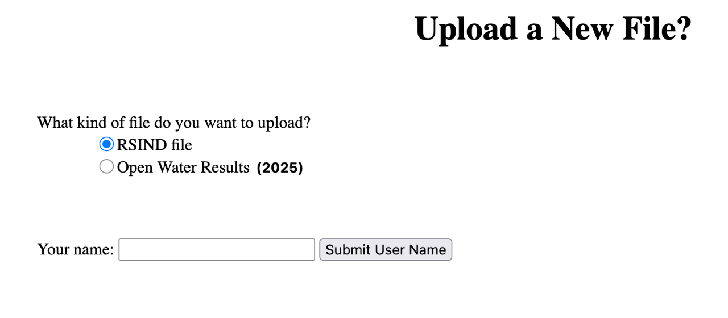

Here are the significant details of this page:

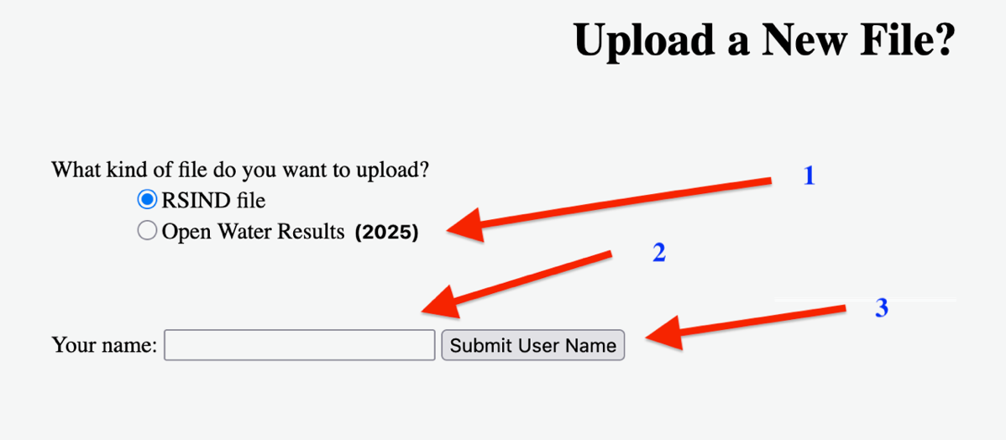

- This is where you choose the type of data to upload.
  - RSIND file is a specially formatted file containing the PAC membership database
  - Open Water Results is a specially formatted file containing the results of an open water swim. The year of the swim is shown.
- The “Your name” field is to be populated with your specific “name” (for example, “Xxxxx”) followed by digits which are the day of the month. For example, if today is March 31, your “name” is Xxxxx31. Tomorrow it would be Xxxxx01.
- The submit button.

Uploading an RSIND file:

(tbd)

Uploading Open Water Result files:

Once you hit the submit button you should see a list of open water events scheduled for the specified year. For example, if the year is 2025 you’d see something like this:

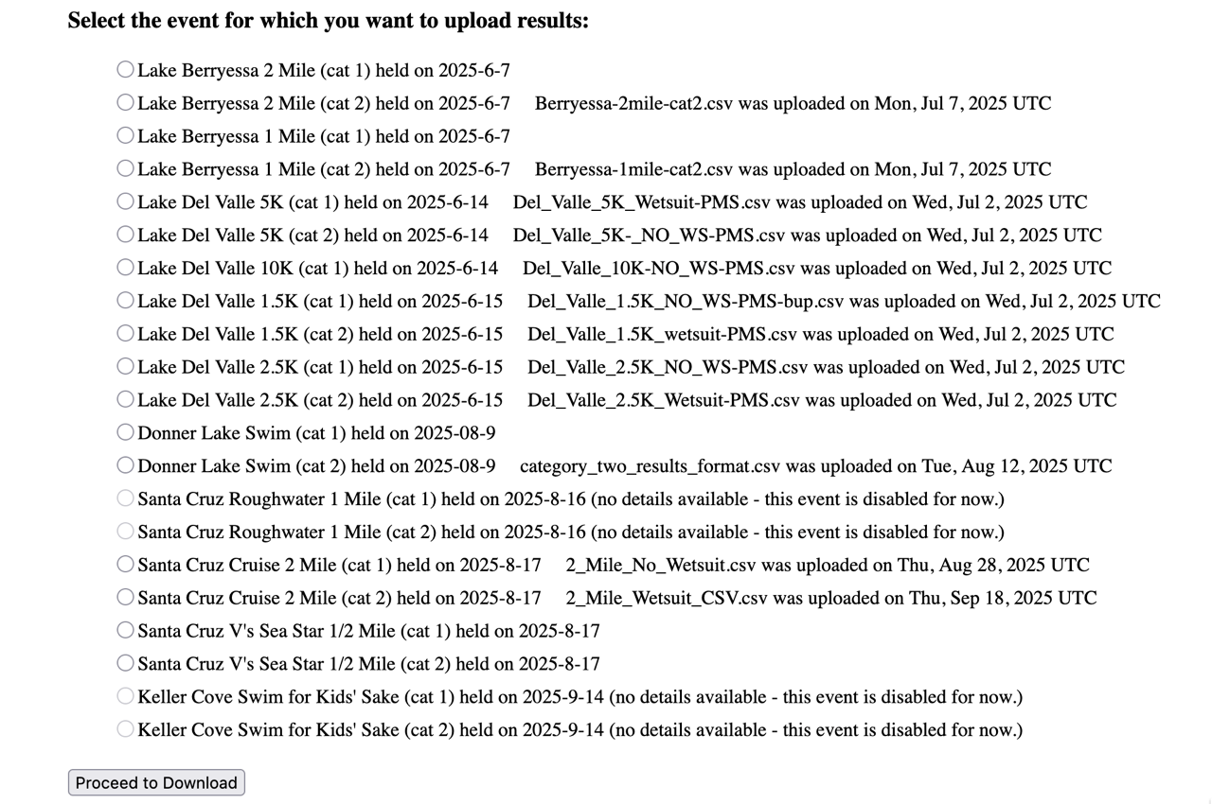

At this point you’d select the event for which you have results and then hit the “Proceed to Download” button. You will then be served the “Upload a New OW File” page. For example, if you selected the first event on the above page the next page you are served after hitting the “Proceed to Download” button would look like this:

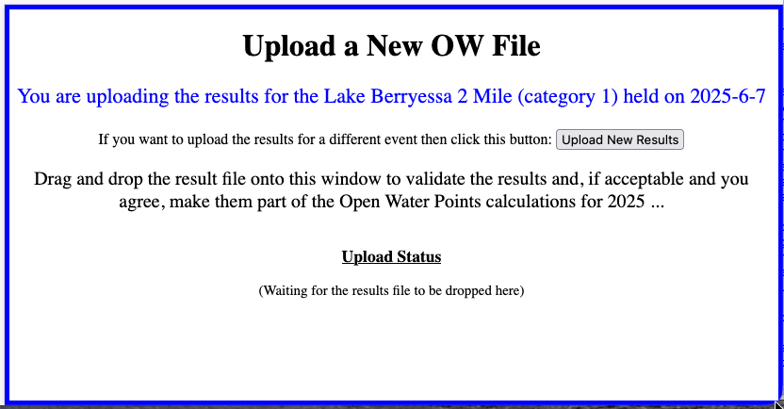

This page will describe the event corresponding to the results you are going to upload. If a previous successful upload has already been performed it will tell you what it is. This is just informational. Regardless, you have two options:
- If something isn't right (e.g. the results you have are for a different event) then click on the "Upload New Results" button and you'll go back to the "Select the event" page.
- If all is good then grab the file and drop it on the page. Notice that the page outline will turn from blue to red. It may take a long time (1-2 minutes or so), depending on the length of the result file.

If you end up on the "Upload Failed!" page then you'll get a description of the problem and more explanation under the "Upload Status". Some common errors:
- you gave it something other than a CSV file. Sorry - only .csv are allowed.
- the name of the file implies results for a different event. This uses a heuristic so therefore it may be wrong. Fix the name if necessary.
- you gave it the same file twice. It doesn't like that. Change the name.
- finally, there are just the typical screw-ups, like not following the required format, swimmers in the wrong age group, swimmers in the wrong order, etc. You just need to explain to the host the problems and let them fix it. The goal is that they are the keepers of the correct results.
  - note that some errors are just "!ERROR" and not necessarily fatal. For example, if the results say a person's age is 26 but it's really 27 then we can ignore that if there are no fatal errors, since fixing this doesn't change their age group. Regardless, we'll still claim the upload failed, but we may decide to use the file in computing anyway.

Here is an example of trying to upload a result file for the wrong open water event:

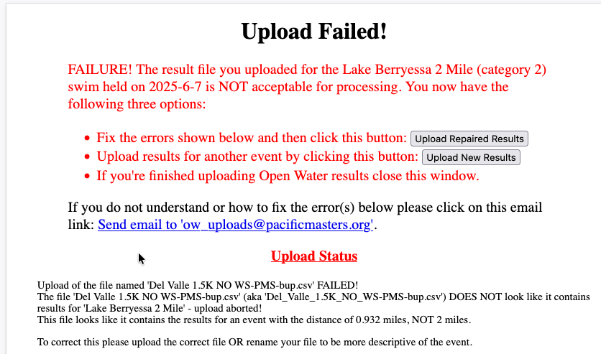

After analyzing the problem(s) explained on the "Upload failed!" page you have these options:
- fix the errors and hit the "Upload Repaired Results" button to try the fixed result file. This is not recommended but you might do it so you can explain to the host how to fix their results.
- give up on this result file and click on the "Upload New Results" button to take you back to the "Select the event" page to try results for a different event.
- quit testing OW results and close the window.
Regardless of which option above you choose you can also send an email with the error summary to "ow_upload@pacificmasters.org", or anyone else if you change the To: field of the email. This is a handy way to send the errors to the host, with necessary editing if you like.

If you end up on the "Upload Success!" then that means the file is probably good to use for assigning OW points. ("Probably" because other things can go wrong when we do the actual point generation.) In this case you have two options:
- Click the "Delete These Results", which just means we won't save them. The file you dropped on the page will remain untouched.
- Click the "Upload New Results" which will send you back to the "Select the event" page to upload another results file. The file that you just uploaded will be kept (but, at this time, not used for anything other than historical backup.)
- quit testing OW results and close the window.
Here is an example of uploading a different event successfully:

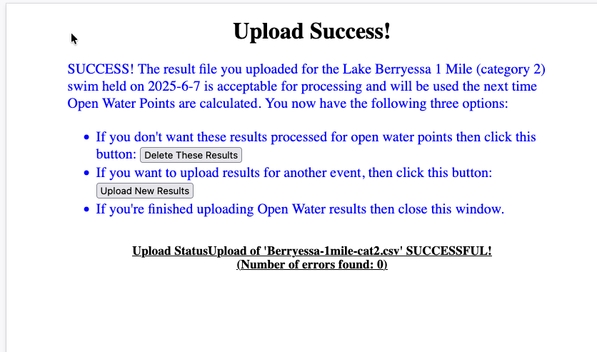

Errors:
If you don’t see the list of events described above then one of two things are possible:
- The year you are working with is not set up for any open water events, or
- There was an error. In this case the error will be cryptic and probably imply that a 404 error occurred. That’s not true, but we give that error so if someone is trying to get in they will believe that there is a configuration problem and not know they got the name/date wrong. You know better. Fix it.

